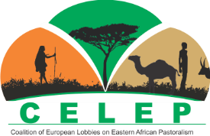

Kenyan dairy sector learning tour – DAY 4
In late March 2018, CELEP organised – in collaboration with Oxfam – a learning tour on small-scale dairying in Kenya for a delegation from three West African countries: Burkina Faso, Mali and Niger. CELEP has already been active on this topic and even organised a roundtable session in the European Parliament on pastoralism and dairying during the 2017 CELEP annual meeting in Brussels. European Union (EU) policies affect dairying in both Eastern and West Africa directly (through development aid) and indirectly (through domestic agricultural and trade policies). Dairying is therefore an important entry point to advocate with the EU for recognition of pastoralism. This is also the trajectory through which the International Land Coalition (ILC) Rangelands Initiative defines key milestone in the Participatory Rangelands Management project, which is funded by the European Commission and seeks to improve pastoralists’ nutrition. The one-week learning tour in Kenya was facilitated by RECONCILE, the CELEP regional focal point in Eastern Africa and the European CELEP members DITSL (German Institute for Tropical and Subtropical Agriculture) and SNV (Netherlands Development Organisation). The CELEP core-group and the European focal point in Véterinaires Sans Frontières (VSF)-Belgium provided input and assured the overall coordination of the tour. Below is a summary of the fourth and final day of the visit.
Introduction
On the fourth and last day of the learning visit (29 March), a workshop was organised by RECONCILE in Nakuru to support a dialogue about lessons learned during the visit, to highlight recent dairy research in Kenya and to discuss the following questions:
- What are the main challenges in both Eastern and West Africa regarding dairy development (with particular attention to pastoralists)?
- What are the solutions offered by farmer organisations, NGOs, agricultural extension and other supporting actors?
- What is the policy environment (national, regional and international) in which this dairy development is taking place?
The workshop gathered around 30 people from the research sector, grassroots organisations and NGOs in Kenya to exchange with the learning tour participants from West Africa. See the final list of participants here. The workshop started with welcoming words from Ken Otieno (RECONCILE and regional focal point of CELEP) and Dr Olivier Kashongwe (Egerton University) and a round of introduction.
Presentations
- Prof. Joseph Matofari, Department of Dairy and Food Science and Technology, Egerton University: See his presentation here. He reviewed Kenyan dairy industry characteristics (cattle and camel populations, production systems, laws and regulations for safety of dairy products, job creation in the dairy sector and advances in dairy research) and particularly focused on the importance of small-scale producers who supply almost 80% (5.2 billion litres per year) of the milk produced in Kenya. There are three types of dairy producers in Kenya: 1) pastoral dairy producers, 2) small-scale agrarian dairy producers, and 3) large-scale dairy producers, some of whom continued to operate ranches that had been sold by colonists after Independence. Strengths and challenges faced by small-scale producers and processors were also emphasised. Main dilemmas are:
  - Informal vs formal market. A lot of milk is sold through the informal sector without a cold chain. The informal sector also touches on problems related to the quality of milk sold in milk bars. Milk-quality issues include antibiotic residues, mycotoxin contamination and a need for more veterinary services to control for diseases.
  - Exotic breeds vs indigenous ones;
  - Smallholder production vs large-scale production;
  - On-farm milk cooling vs centralised cooling;
  - On the policy level: policies to favour informal and private-sector vs formal and government-centred laws. Implications of making it illegal to sell raw milk informally.
- Dr Tobias Okeno, Tatton Agricultural Park (TAP) Research Institute hosted at Egerton University. See his presentation here. He started with the importance of the Kenyan dairy sector and its central place in the vision of Kenyan industrialisation 2030. The Kenyan dairy sector is very dynamic and contributes a lot to agricultural GDP (40%) and overall GDP (4%). A breeding programme at TAP was developed with the aim of increasing milk production for food security for poor families and to enable them to earn higher incomes. TAP targeted improving breeding in relation to local environmental conditions such that crossbreds were produced to bring together the benefits of higher production capacities from imported breeds with disease resistance from local breeds. Currently, a transition is ongoing from the traditional extensive system towards commercial dairy farming. Dairy-sector challenges include a lack of specialisation (heifer production, feed production), feed scarcity, a need for improved breed selection, high postharvest losses, etc.

- Mr Ibrahim Diallo, Union Nationale des Mini-laiteries et des Producteurs laitiers de Burkina Faso – UMPLB (National Union of Mini-Dairies and Milk Producers of Burkina Faso). See his presentation here. He gave an overview of dairy production and consumption in West African countries. Currently, local production is satisfying only 50% of market demand. Based on pastoral dairy production, many different actors contribute to the dairy value chain connecting rural producers and urban consumers. The sector’s main challenge is competition from milk powder from European and other countries that is imported at a very low price. This seriously threatens local production. Other challenges include low productivity, scarcity of feed and limited access to market. The livestock production system is more oriented towards beef than to milk.

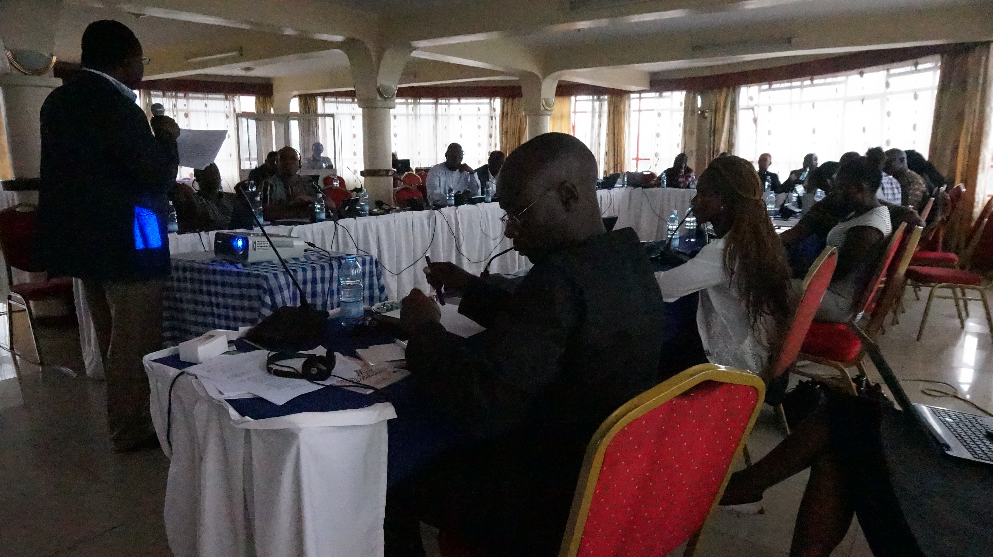
Workshop in Nakuru to draw lessons from Kenya dairy sector learning tour (Photo: Azara Remalia Nfon Dibie)
Discussion
After the presentations, the group entered into a lively and constructive debate. The discussions focused on several important points including (i) production practices; (ii) access to artificial insemination; and (iii) the role of civil society organisations to reinforce the bargaining power of smallholder dairy farmers. The Kenya vision 2030 was identified as a key document paving the road for dairy sector development that could be a useful example for West Africa. Participants also pointed out that there was a time gap between Eastern Africa and West Africa in dairy development, as English colonists emphasised it more than did the French. The low tax on dairy imports specified in EU agreements with the Economic Community of West African States (ECOWAS – CEDEAO in French) represents a real threat to the West African dairy sector. In Kenya, this has been blocked by the fact that the country has negotiated exceptions within World Trade Organization (WTO) agreements for strategic sectors (including dairy) that contribute to the livelihoods of many poor families. However, in the coming years, this will be re-negotiated.
Validation of CELEP statement “Pastoral dairying in Eastern Africa: how could Europe support it?”
The statement was presented to participants by Ken Otieno (RECONCILE), applying aspects of the Eastern African context that could be relevant for West Africa. See his presentation here and the draft statement here. However, there was a disagreement on the validation with issues raised by participants from both sides of the continent, summarised in the following recommendations:
- Eastern and West African representatives should come together to review the statement in order to validate a pan-African position on dairy production in pastoralist systems. The West African representatives indicated that they have a number of statements which can be drawn on for this, but they need to come together first and propose a common position for their region.
- Increase lobbying through nationwide, regional farmer/ stakeholder organisations to protect local dairy production. There is also a need to synchronise actions to protect key development sectors (such as dairy) at the continental level during international negotiations such as with the WTO.
- Develop exchange programmes that can help build capacity in West African technical aspects of dairy production.
Some questions remained following the discussion of the statement, including: who in Eastern and West Africa should be involved in the writing, discussion and presentation of the statement (civil society organisations, farmer and other stakeholder organisations, decision-makers from government or all) and who will pilot the process?
Lessons learned – analysis from the West African perspective
The West African delegation affirmed that they have learned more about the political evolution of the dairy sector in Kenya and the means by which production was boosted over the last twenty years. They were also informed about remaining challenges. The main weaknesses and strengths of the Kenyan dairy sector they identified were the following:
Strengths | Weaknesses
- The sector in Kenya has no problem with milk powder imports thanks to an enabling policy framework and the political will to temporarily protect the domestic market through the exploitation of special safeguard mechanism (SSM) clauses. This was achieved thanks to strong local advocacy.  - The sector is robust with milk-processing facilities developed and over 20 years of experience.  - There is an increased and growing demand for milk from urban consumers.  - Entrepreneurs are ready to invest.  - There are good breeds available. | - Small-scale producers are not highly valued (socially and politically), although they produce 80% of milk. Their interests are insufficiently taken into account.  - Small-scale producers no longer receive subsidies. In addition, they are not supported by a system that improves and standardises milk quality, and good-quality production services are not yet provided.  - There is high seasonality in milk production because of the dry season, which leads to lack of water and grass.

The group from West Africa concluded that there is a need to strengthen dialogue, both internally and with other stakeholders, to continue collaborating and advocating together for smallholder dairying. Some questions will also need to be resolved in the West African context including:
- How to organise the informal sector?
- How to better link small-scale farmers with consumers?
- When exotic breeds are preferred and have more potential for milk production, and what are the implications within the constraints of current smallholder farming systems?

